

root@cyberster:~$ whoami
> hanzallah — soc_intern
DAY
08–09
FILE INTEGRITY MONITORING
// candidate Hanzallah
// program Cyberster — Cybersecurity Internship (Batch 2)
// tutor Abdullah Zia
[ STATUS: TASKS COMPLETE — READY FOR REVIEW ]
// 01 OVERVIEW & FIM CONCEPT

File Integrity Monitoring (FIM) is a core detection capability that tracks changes to critical files and directories. Wazuh implements FIM through its syscheck module, which watches specified paths and generates alerts when files are created, modified, or deleted — recording who made the change, what changed, and when.
This week's objective was to move syscheck from its default configuration to a deliberate, scoped configuration covering key system directories on both the Linux and Windows agents, then validate detection by generating controlled test events.
$ Why FIM Matters
A large share of attacker activity involves modifying files — persistence mechanisms drop files into startup directories, malware overwrites legitimate binaries. FIM is the control that catches that kind of change as it happens.

// 02 MONITORED PATHS & CONFIGURATION SCOPE

$ Linux Agent (Ubuntu Server / Kali)
Paths: /etc and /var/log
$ Windows Agent (Windows 11 Host)
Path: C:\Windows\System32
$ Key Attributes Configured
- realtime="yes" — uses OS-level filesystem notifications to alert immediately on change, rather than waiting for the scheduled scan.
- report_changes="yes" — captures the actual diff content for text files. Set on /etc and System32; left at default on /var/log to avoid alert noise from constantly-changing logs.
- frequency — controls the scheduled scan interval (300–900s) for directories not in realtime mode. Does not affect realtime paths.

// 03 OSSEC.CONF — SYSCHECK CONFIGURATION

$ Linux Agent (Ubuntu Server)
Edited /var/ossec/etc/ossec.conf on the Ubuntu Server agent (192.168.56.10):
<syscheck>
<disabled>no</disabled>
<directories realtime="yes" report_changes="yes">/etc</directories>
<frequency>600</frequency>
</syscheck>

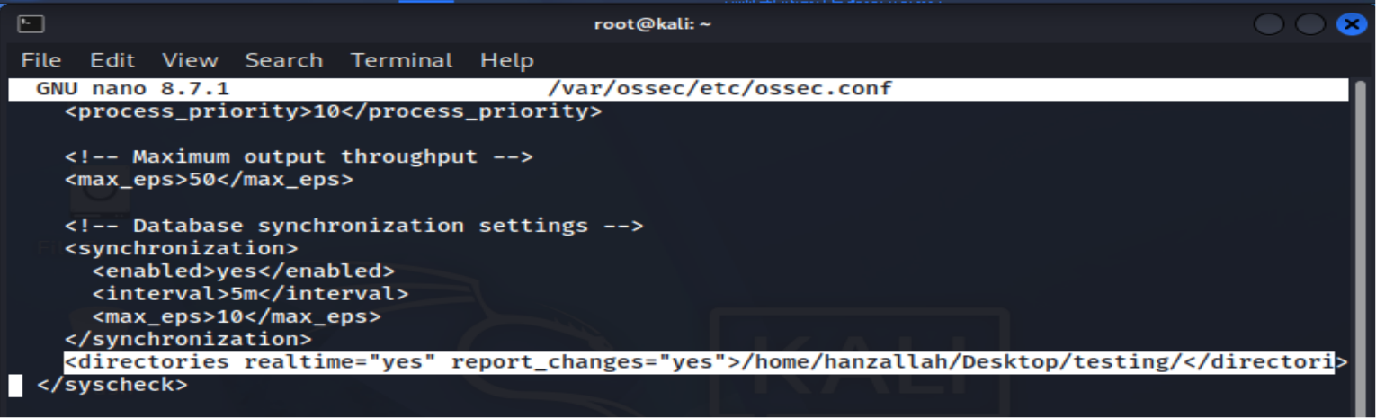
$ Windows Agent (Windows 11 Host)
Edited C:\Program Files (x86)\ossec-agent\ossec.conf on the Windows 11 host agent (192.168.56.1):
<syscheck>
<disabled>no</disabled>
<directories realtime="yes" report_changes="yes">C:\Windows\System32</directories>
<frequency>600</frequency>
</syscheck>

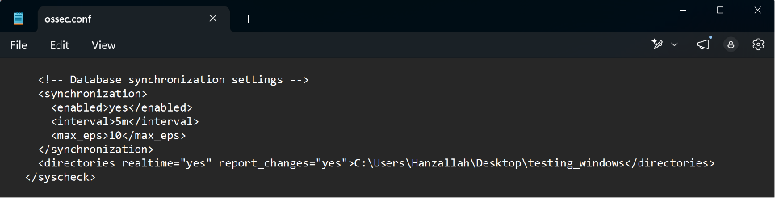
// 04 APPLYING THE CONFIGURATION

$ Restart Agent Services
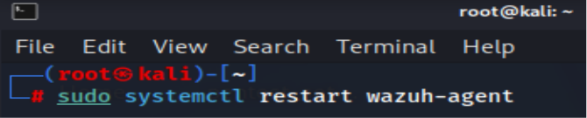
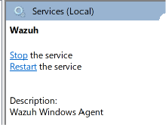
$ Confirm Agent Status
Both agents were confirmed as Active in the Wazuh dashboard (Agents view) after restart, with syscheck showing as running under the agent's module status.
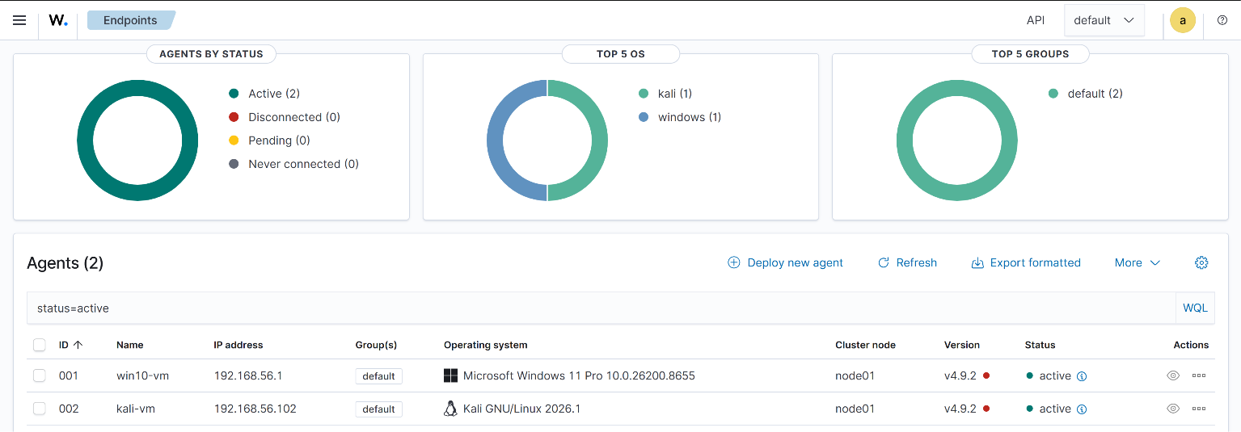

// 05 TEST EVENT GENERATION

$ Linux-AGENT

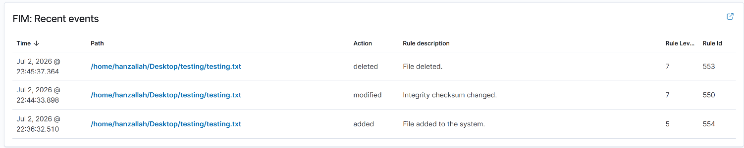

$ Windows-AGENT

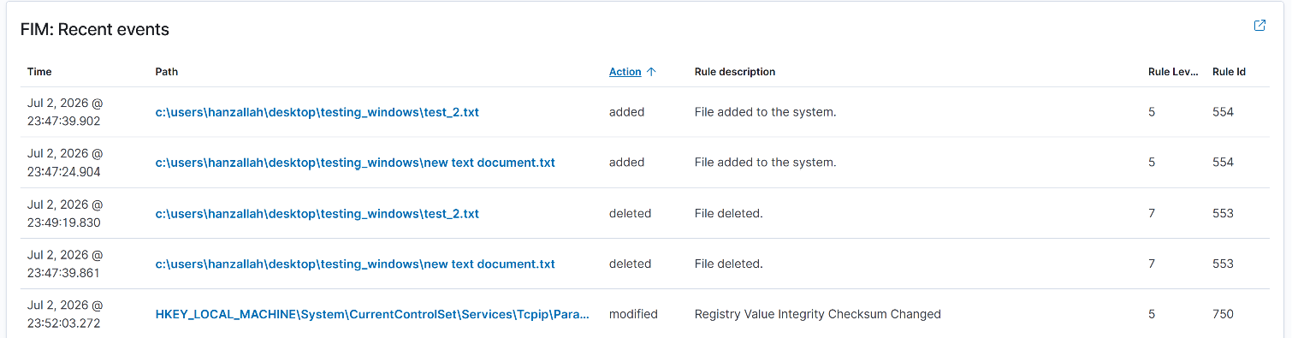
Each command set produces three discrete syscheck events per agent: Added, Modified, Delete
// 06 ALERTS IN THE WAZUH DASHBOARD

Filtered Security Events by rule.groups: syscheck to isolate FIM alerts. Opened each alert to inspect the file path, event type, reporting agent, and timestamp.
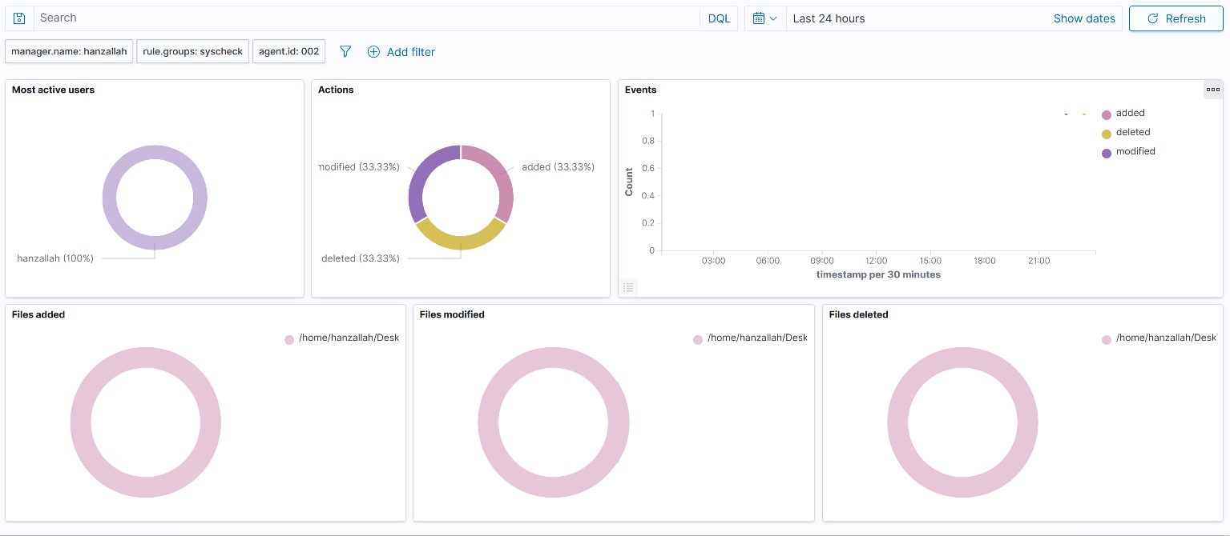
Wazuh dashboard — syscheck alert list, filtered by rule group

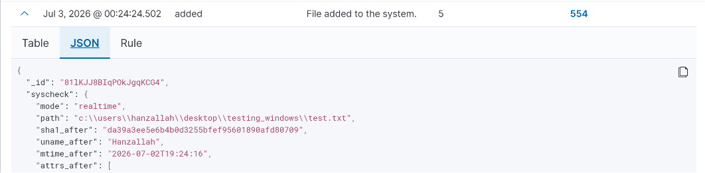
Alert detail — Added event, full JSON

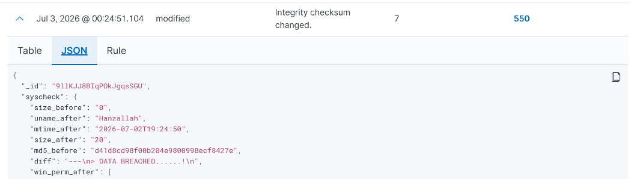
Alert detail — Modified event, diff content

// 07 FIM EVENT ANALYSIS

Summary of the six test events generated across both agents. Fill in exact timestamps and the active user account from the alert detail once captured.

FILE PATH | CHANGE TYPE | TIMESTAMP | AGENT | USER
/etc/fim_test.txt — created | Added | TBD | Ubuntu-Server-Wazuh | TBD
/etc/fim_test.txt — modified | Modified | TBD | Ubuntu-Server-Wazuh | TBD
/etc/fim_test.txt — deleted | Deleted | TBD | Ubuntu-Server-Wazuh | TBD
C:\Windows\System32\fim_test.txt — created | Added | TBD | Windows-11-Host | TBD
C:\Windows\System32\fim_test.txt — modified | Modified | TBD | Windows-11-Host | TBD
C:\Windows\System32\fim_test.txt — deleted | Deleted | TBD | Windows-11-Host | TBD

$ Next Steps in a Real Environment
If a change like this appeared in production and the responsible user could not be immediately identified, the next step would be to correlate the syscheck alert with authentication logs (auth/sshd or Windows Security event decoders) around the same timestamp to identify which account was logged in at the time. This would be cross-checked against the asset owner and any recent change-management tickets to rule out authorized maintenance. If no legitimate explanation surfaced, the file would be preserved for forensic review, the host isolated from the network to prevent lateral movement, and the finding escalated per the incident response runbook rather than closed as a false positive.

